OPTIMIZING TELECOM OPERATIONS WITH

SEGMENTATION AND CHURN PREDICTION

DANDU NEHA
dept.Computer Science and Engineering Institute of Aeronautical Engineering
Hyderabad Telangana,India 21951A05B8@iare.ac.in

MOHAMMED AMEESHA
dept.Computer Science and Engineering Institute of Aeronautical Engineering Hyderabad Telangana,India 21951A05A4@iare.ac.in

MUKKA DHEERAJ
dept.Computer Science and Engineering Institute of Aeronautical Engineering Hyderabad Telangana,India 21951A0538@iare.ac.in

K.SANGEETA
Assistant Professor of CSE
Institute of Aeronautical Engineering
Hyderabad Telangana,India
K.SANGEETA@iare.ac.in

Abstract— Client turnover is a significant issue for large organizations, particularly within the telecom sector, where it has a direct impact on profitability. To address this, telecom providers are increasingly focusing on developing predictive models to forecast customer churn and reduce its adverse effects. Identifying the key factors influencing churn is critical for implementing effective retention strategies. This research presents the development of a churn prediction model designed to help telecom companies identify customers at a high risk of leaving. The study involves exploring various data analysis techniques and presenting the results through graphical visualizations. Using machine learning methods, the model leverages large-scale datasets and introduces an innovative approach to feature design and selection. Historical customer data from previous months was utilized for training, evaluation, and validation of the model. Four machine learning algorithms were tested: Logistic Regression, XGBoost, Gradient-Boosted Machines (GBM), Random Forest, and Decision Trees. To further improve model accuracy, parameter tuning was applied during the training phase. The primary objective of this work is to enhance telecom operations by optimizing customer segmentation and churn prediction, ultimately improving both operational efficiency and customer retention.

Keywords— Customer churn, predictive modeling, telecommunications operations, machine learning applications, feature selection techniques, customer grouping, and enhancing operational efficiency.

INTRODUCTION
The telecommunications industry is facing increasing challenges in maintaining customer loyalty and satisfaction. Customer churn, which occurs when a customer discontinues services, is a significant issue for telecom companies, leading to substantial revenue loss and high acquisition costs. In response to this challenge, telecom providers have turned to advanced analytics and machine learning techniques to predict and manage churn more effectively. By anticipating customer behavior and segmenting them based on various characteristics, telecom companies can design personalized retention strategies that reduce churn and optimize overall operations.
This paper delves into the role of machine learning in optimizing telecom operations, particularly focusing on churn prediction and customer segmentation. These methods allow telecom operators to identify high-risk customers, predict churn more accurately, and implement customized retention plans. The combination of machine learning and segmentation strategies provides a pathway to more efficient and targeted customer retention practices, leading to improved operational performance and customer satisfaction.
Effective churn prediction not only assists in retaining customers but also provides insights into the underlying causes of churn. These insights can drive strategic decisions in product development, customer service enhancements, and targeted marketing campaigns. Furthermore, reducing churn rates directly increases customer lifetime value and provides a more stable revenue base.

To ensure reliability, the model utilizes clean, well-prepared data and employs cross-validation techniques to assess its performance across multiple subsets. Regular hyperparameter tuning and monitoring help optimize the model’s accuracy. Furthermore, testing the model on diverse customer segments ensures it can generalize effectively to new, unseen data, maintaining consilimistent performance over time.The project aims to build a scalable and accurate churn prediction system that can be seamlessly integrated into a telecom operator's existing infrastructure. By doing so, telecom companies can shift from reactive to proactive customer relationship management, improving customer satisfaction and loyalty in a fiercely competitive market.
- Machine Learning for Churn Prediction
Churn prediction has traditionally relied on basic statistical methods, but recent advancements in machine learning have revolutionized this approach. Machine learning allows for the analysis of large datasets, uncovering complex patterns that traditional methods might miss. By examining customer data such as service usage, payment history, complaints, and call records, machine learning models can predict the likelihood of a customer leaving, providing telecom companies with valuable insights.
Among the most widely used machine learning techniques for churn prediction are Logistic Regression, Random Forests, Gradient Boosting Machines (GBM), and XGBoost. Logistic Regression, a simple yet powerful algorithm, is effective for binary classification tasks like churn prediction. However, more complex methods, such as Random Forests and XGBoost, provide better performance by capturing intricate patterns in the data. These algorithms work by aggregating multiple decision trees to make predictions, thereby reducing overfitting and improving generalization.
The advantage of using machine learning for churn prediction lies in its ability to adapt over time. As telecom companies gather more data, these models can be retrained to reflect the latest customer trends and behaviors. This adaptability ensures that the churn prediction remains accurate and relevant, helping operators stay ahead of potential issues. Wei and Chiu highlighted the value of utilizing telecom data for churn prediction, particularly using data mining approaches to analyze call records and usage pattern . Similarly, Qureshi et al. emphasized the effectiveness of machine learning in predicting telecom customer churn, showcasing its ability to handle complex, dynamic customer data.
- Customer Segmentation for Effective Retention
Churn prediction identifies customers likely to leave, while segmentation helps telecom companies understand their distinct characteristics and tailor retention strategies accordingly. Segmentation involves categorizing the customer base into smaller groups based on common attributes, such as demographics, service usage, or behavioral patterns. This approach enables the creation of personalized retention plans that address the unique needs of each segment.
For example, high-value customers who contribute significantly to revenue might be offered exclusive loyalty programs, special promotions, or premium services to encourage retention. In contrast, price-sensitive customers may respond better to discount offers or flexible payment options. By identifying and addressing the specific requirements of these segments, telecom companies can allocate resources more effectively, prioritizing the customers who require focused attention to improve overall retention rates.
A significant challenge in customer segmentation is dealing with class imbalance. In typical telecom datasets, most customers are not at risk of churning, which can result in an over representation of retention cases in predictive models. Techniques such as oversampling or under sampling help address this imbalance, ensuring that churn prediction models are not biased toward the majority class. This enables more accurate predictions and segmentation, ensuring that telecom companies can target at-risk customers effectively.
Combining churn prediction with segmentation offers a powerful strategy for customer retention. Once churn-prone customers are identified through predictive models, segmentation allows telecom companies to understand the factors driving their behavior. This understanding enables the development of highly targeted retention strategies, which are more likely to be effective than one-size-fits-all approaches.
Incorporating segmentation also enhances the customer experience. By grouping customers based on their preferences and service interactions, telecom companies can provide a more personalized service, which is key to building long-term loyalty. This customer-centric approach not only reduces churn but also improves satisfaction, leading to greater customer retention.
Segmentation also facilitates better resource allocation. Instead of treating all customers the same, telecom companies can focus their efforts on the most valuable or at-risk segments, ensuring that retention strategies are both cost-effective and impactful. This approach optimizes marketing spend and customer service resources, improving both operational efficiency and retention outcomes.
- Integrating Systems for Telecom Optimization
To effectively implement churn prediction and segmentation strategies, telecom companies require a comprehensive, integrated system that facilitates data analysis and decision-making. This system should encompass data preprocessing, predictive modeling, segmentation, and actionable insights within a unified framework. Such integration enables providers to make real-time, informed decisions to enhance customer retention.
The first step in this system is data preprocessing, where raw customer data is transformed into a structured, analyzable format. Telecom companies gather extensive data from sources such as billing records, customer interactions, and service usage. Preprocessing ensures the data is accurate, consistent, and analysis-ready by addressing errors, filling missing values, and standardizing variables.
Following preprocessing, predictive modeling utilizes machine learning algorithms to identify customers at high risk of churning. Techniques such as Random Forests, Gradient Boosting Machines (GBMs), or XGBoost analyze historical data to assign churn probability scores to individual customers. These predictions help prioritize retention efforts on high-risk customers. Continuous retraining of the models with updated data ensures the predictions remain accurate and relevant over time.
Customer segmentation is the next phase, where customers are grouped based on shared characteristics. This segmentation allows telecom providers to create tailored strategies for different customer groups. Clustering methods like K-Means or hierarchical clustering are commonly applied to identify patterns and group customers with similar traits. Based on these segments, personalized retention strategies—such as targeted discounts, loyalty programs, or specialized customer support—can be deployed to improve retention outcomes.
Finally, decision support systems provide actionable insights from the churn prediction and segmentation models. These systems offer recommendations for retention strategies based on real-time data, allowing telecom companies to respond quickly and effectively to churn risks. For example, decision support systems might highlight the most valuable customers who are at risk of leaving, suggesting retention tactics such as exclusive offers or personalized communications.
By integrating churn prediction, segmentation, and decision support into a single system, telecom companies can improve their operational efficiency and effectiveness in retaining customers. This integrated approach ensures that all customer interactions are informed by data-driven insights, leading to more targeted, personalized, and successful retention efforts.

II.LITERATURE SURVEY
In a recent work telecommunications industry faces increasing challenges in improving customer retention, with customer churn being a significant concern that affects profitability and growth. Churn represents the rate at which customers stop using a service, and retaining existing customers is far more cost-effective than acquiring new ones. To tackle this issue, telecom companies are leveraging advanced methods such as machine learning (ML) for churn prediction and customer segmentation. These tools allow providers to anticipate customer behavior and develop targeted strategies to enhance retention. This review explores key research and methodologies that have advanced the understanding of churn prediction and segmentation in the telecom industry.

Understanding Churn Prediction in Telecom
Customer churn has been a central concern in the telecom industry for many years, influencing a range of strategies aimed at improving customer retention. A substantial amount of research has been dedicated to analyzing the factors contributing to churn and developing predictive models to estimate which customers are at risk of leaving. Early work, such as that by Gerpott et al. (2001), identified key drivers of churn, including customer dissatisfaction, service quality, and price sensitivity. Their study emphasized the importance of retention and loyalty in reducing churn, pointing out that proactive measures based on churn prediction could help mitigate the problem [1].
The application of data mining techniques to churn prediction by analyzing telecom call data. They found that analyzing various customer attributes, such as call frequency and service usage, could lead to better identification of churn risks. Their research underscored the potential of data mining to help telecom companies understand customer behavior more comprehensively [2]. More recent work demonstrated how machine learning algorithms can be used to enhance churn prediction. By employing models such as decision trees and neural networks, the authors were able to predict customer churn more accurately than with traditional methods. Their work highlighted the effectiveness of machine learning in managing churn prediction by examining both demographic and behavioral data[3].

  - Machine Learning Models for Churn Prediction
Machine learning plays a pivotal role in churn prediction, as it can process vast datasets and uncover intricate patterns that traditional approaches often overlook. Different machine learning models have been designed for churn prediction, each providing specific benefits based on the data characteristics and the complexity of the patterns involved.
A study on proactive churn prevention, showing that machine learning models could be used to recommend alternative plans to at-risk customers. While such strategies proved effective in some cases, the authors noted that a predictive model is crucial for targeting the right customers to maximize retention[4]. Their findings emphasized that churn prediction models must be accurate in identifying high-risk customers to ensure that retention efforts are focused where they are needed most.
The use of multi layer perceptron neural networks (a type of deep learning model) for churn prediction. He found that neural networks, which are capable of handling non-linear relationships, provided higher accuracy compared to traditional statistical models. These networks learn from data and continuously improve as more data is incorporated, making them particularly useful for churn prediction in dynamic environments like telecommunications[5].
However, one of the major challenges in churn prediction is the imbalance between churners and non-churners in customer datasets. Many churn prediction datasets have a high proportion of customers who are not at risk of leaving, leading to biased models.A research addressed this issue by reviewing various techniques, such as oversampling, under sampling, and synthetic data generation, to handle class imbalance. These methods help improve the performance of predictive models, ensuring they are not skewed toward predicting non-churners[8].

Customer Segmentation for Tailored Retention Strategies
Churn prediction helps identify customers likely to leave, while customer segmentation enables telecom companies to customize their retention efforts. Segmentation involves grouping customers based on common traits like demographics, behavior, or service usage patterns. This method allows companies to create targeted strategies that align with the needs and preferences of specific customer groups, ultimately enhancing retention rates.
By using segmentation, telecom companies can create personalized retention. This strategy enhances customer loyalty and reduces churn by addressing the unique reasons customers may consider leaving[7].The importance of using clustering algorithms, such as K-means and hierarchical clustering, to segment customers based on similarities in behavior and preferences. These segments can then be targeted with specific retention strategies, such as loyalty programs or personalized discounts, that align with their particular needs[7].
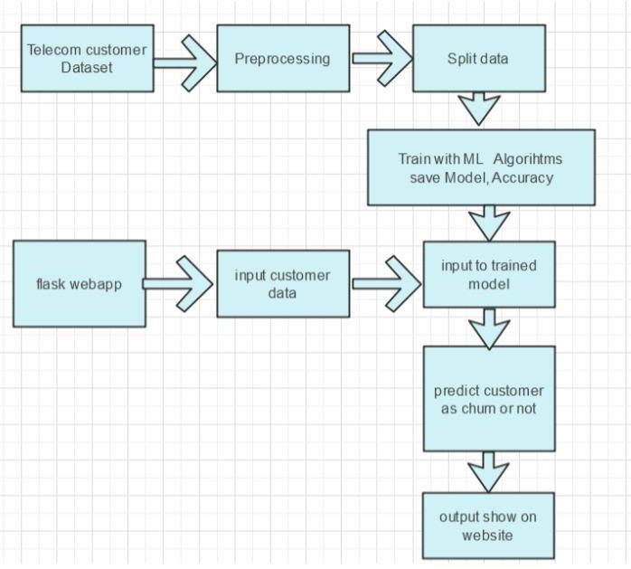
Furthermore, Segmentation helps telecom companies focus resources on high-risk or valuable customers, enabling effective retention strategies .It was emphasized big data's role in enhancing churn prediction [14], while it was also highlight the value of customer feedback in improving retention models [15]. These approaches enhance loyalty and reduce churn efficiently.

III. EXISTING METHODOLOGIES
Traditional methods for customer churn prediction, such as rule-based systems and statistical models, face notable limitations. Rule-based systems, while simple and interpretable, rely on fixed thresholds to identify at-risk customers, making them inflexible to changing customer behaviors and requiring frequent manual updates. Similarly, statistical models like logistic regression offer quantitative insights by analyzing historical data but struggle to handle the complexity and scale of modern telecom datasets. These approaches often fail to adapt to evolving patterns in customer behavior, limiting their effectiveness in dynamic and data-intensive environments.
Existing research further underscores these challenges. Studies emphasize the importance of big data analytics and customer feedback but lack integration with advanced machine learning techniques, reducing their versatility. Class imbalance in churn datasets, a persistent issue, is inadequately addressed, as seen in,where resampling methods risk overfitting and fail to generalize well across datasets. Additionally, research like often lacks comprehensive model evaluations and real-world applicability, overlooking external factors such as market trends and customer preferences. To address these gaps, the proposed system leverages advanced machine learning techniques capable of dynamically adapting to shifting customer behaviors, offering greater precision and flexibility. By integrating big data analytics and modern predictive methods, the system provides a more robust and comprehensive solution to churn prediction in telecom sector.

IV.PROBLEM STATEMENT
This project focuses on tackling the challenges faced by the telecommunications sector caused by customer churn, where subscribers discontinue their services, leading to revenue loss and increased customer acquisition costs. The goal is to develop a machine learning model that predicts churn by analyzing user behavior, service usage patterns, and demographic data. By accurately identifying customers who are likely to leave, telecom companies can take proactive steps such as offering personalized deals or improving services. The aim is to enhance customer satisfaction, reduce churn rates, and increase profitability by using advanced algorithms to analyze historical data and identify key factors contributing to churn.

V.PROPOSED APPROACH
The suggested method forecasts customer churn by examining usage behaviors, service engagement, and demographic factors. It incorporates feature engineering, under-sampling, and tree-based models to address data imbalances and enhance predictive accuracy. To improve performance further, ensemble techniques and deep learning approaches are employed, offering precise, flexible, and scalable strategies for customer retention

Fig. 1. The System Design

Telecom Customer Dataset
The Telecom Customer Dataset offers an extensive collection of information on customer profiles and behaviors, covering demographic data, service preferences, and usage patterns. It includes key features such as customer age, geographic region, subscription types, usage data for calls and internet, payment records, and interaction history with customer support. These diverse data points provide a detailed view of how customers engage with the telecom services.Analyzing this dataset allows businesses to identify key trends and behaviors associated with customer retention and churn. This makes it a valuable tool for developing predictive models that can pinpoint customers at risk of leaving. The insights gathered from this data enable telecom companies to improve customer satisfaction, implement targeted retention strategies, and reduce churn effectively. However, the dataset needs more detailed information and further refinement to capture a broader range of customer experiences and factors influencing churn. This study utilized publicly available datasets from the Kaggle platform.

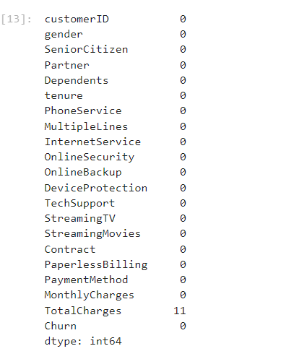

Fig. 2. Total Datasets Features

Web Application Interface
The entire system operates within a web-based interface to facilitate interaction with the system. To make the churn prediction accessible, a web application is built using the Flask framework. Users can upload datasets or provide individual customer details to obtain churn predictions. The application ensures results are presented in a clear and user-friendly format.. The model is integrated into the web app to provide real-time churn predictions based on the submitted data.

Data Preprocessing
Data preprocessing is an essential first step in preparing a dataset for machine learning, aimed at improving model performance and ensuring accurate predictions. This process involves several key tasks: cleaning the data to remove errors or inconsistencies, addressing missing values by imputation or removal, and converting categorical variables into numerical formats using methods like one-hot encoding or label encoding. Additionally, numerical features are scaled through normalization or standardization to ensure all variables are on a comparable scale. Normalization, in particular, prevents any feature from disproportionately affecting the model due to differences in scale, leading to more balanced and efficient learning.

Data Splitting
Following data preprocessing, the dataset is divided into two subsets: one for training and the other for testing. Typically, 70-80% of the data is used for training, while the remaining 20-30% is set aside for testing. This division allows the model to learn patterns from the training data while being evaluated on data it has not seen before in the testing set. This technique helps mitigate overfitting and ensures that the model generalizes well to new, unseen data.

Model Training and Evaluation
Training a model involves choosing a suitable algorithm, such as Random Forest or Logistic Regression, and using the training data to help the model learn the relationships between features and churn. The model's performance is then assessed using metrics like accuracy, precision, recall, and F1 score to evaluate how effectively it predicts churn. Once evaluated, the model is saved for future application, often with tools like joblib, enabling deployment in real-world scenarios without needing to retrain.

User Input Processing
Once users input their data, the application validates the input, checking for missing or incorrect values. The data is then transformed into the format required by the model, ensuring compatibility before prediction.

Model Integration and Prediction
The pre-trained model is embedded into the application, where it processes the input data to predict customer churn likelihood. This prediction is then displayed for user action. To build a churn prediction model using machine learning, we begin by collecting and preprocessing key data such as demographics and usage patterns. Feature engineering is applied to improve the input data, followed by training suitable algorithms (e.g., Random Forest, XGBoost) on historical datasets and validating their performance. Hyperparameter tuning is conducted to optimize the model, which is then evaluated for accuracy. Continuous learning is integrated to refine predictions over time.

Obtained Results
The final prediction is displayed clearly in the user interface, indicating the likelihood of churn. The output may also suggest potential retention strategies based on the prediction, providing businesses with actionable insights.

VI.TECHNIQUES USED

1.Random Forest
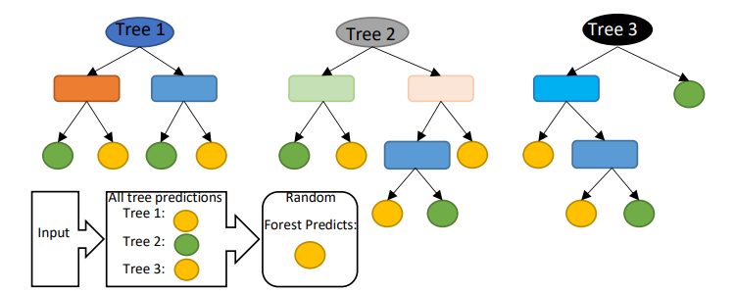
Random Forest is an ensemble learning method composed of multiple decision trees that collectively determine the output through majority voting or averaging.
Fig. 3. Random Forest
Unlike decision trees, it uses a random subset of features for splitting, which reduces overfitting and improves robustness. Random Forest handles high-dimensional data effectively, requires no feature selection, and is easy to implement. Its parallelizable structure allows efficient training, offering a balance between speed and strong generalization performance.

2. Logistic Regression
Logistic Regression (LR) was applied in a study to predict printing machine downtime by analyzing real-time data for imminent failures. The study used historical machine data to train ML models like RF, XGBoost, and LR for failure prediction. Performance metrics such as cross-entropy, AUC, ROC, precision-recall curve, false positives (FP), true positives (TP), false negatives (FN), true negatives (TN), and probability calibration curves were evaluated. While all models showed comparable performance in terms of ROC, RF and XGBoost outperformed LR at specific decision thresholds.
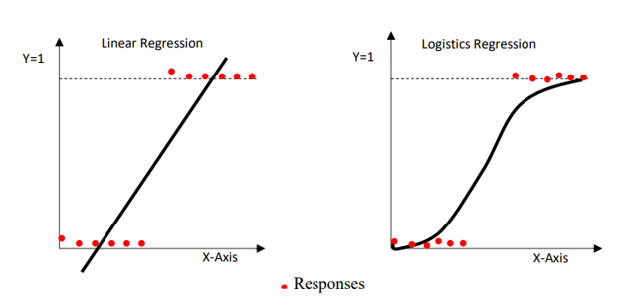

Fig. 4. Logistic Regression

3. Decision Tree
A Decision Tree (DT) is a hierarchical structure consisting of nodes and branches. It includes root nodes, intermediate nodes, and leaf nodes. Decision Trees are often used for tasks like feature selection and classification.
DT models are widely applied in fields such as character recognition, medical diagnosis, and voice recognition. They excel in breaking down complex decision-making processes into simpler, interpretable decisions by recursively partitioning the feature space into smaller subspaces. This makes them a valuable tool for interpretable machine learning solutions.

- XGBoost
XGBoost is an ensemble learning technique that leverages the combined predictive power of multiple models to enhance accuracy. It uses weak learners, which individually have high bias and perform only slightly better than random guessing. However, each weak learner contributes unique insights, and their collective combination forms a strong learner. This strong learner effectively reduces both bias and variance, improving the overall predictive performance.

- Overview of Results
By the end of the project, we created a machine learning model capable of analyzing customer data to determine if a client had canceled their subscription. This model proved to be significantly more effective than traditional methods for predicting customer retention or churn..The dataset was split into 80% for training and 20% for validation. Hyperparameter tuning and validation were performed to optimize the models. Feature engineering, including transformations and selection methods, was applied to prepare data for machine learning algorithms.
The dataset posed a challenge due to its imbalance, with only 5% of entries representing customer churn. This issue was addressed through under-sampling and tree-based algorithms that are less affected by imbalanced data.

- Model Accuracy
Four tree-based methods were selected for their effectiveness in churn prediction: Decision Tree, Random Forest, and Gradient Boosting Machine (GBM). These models demonstrated strong predictive performance and suitability for the task.
TABLE 1
COMPARISION OF MACHINE LEARNING MODELS FOR CUSTOMER CHURN PREDICTION

Model | Accuracy Score
Decision Tree Classifier | 0.94
Random Forest Classifier | 0.95
Logistic Regression | 0.93
Gradient Boosting Classifier | 0.96

To enhance efficiency, the proposed system automates churn prediction using machine learning, processing customer data quickly while maintaining strong performance. Precision is improved through advanced algorithms like ensemble learning and deep learning, which identify complex patterns and reduce errors. High a is achieved by continuously updating the model with evolving customer data, along with regular hyperparameter tuning and validation, ensuring reliable and precise predictions over time.

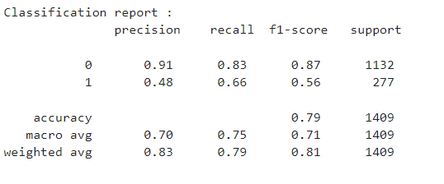

Fig. 5. Random Forest Score

B.Evalution
The customer churn prediction system provides a user-friendly interface where users can input customer details such as demographics, transaction history, and usage patterns to assess the likelihood of churn. The system is powered by a backend machine learning model trained to analyze these inputs and predict customer churn with high accuracy. After submission, the model processes the data and delivers the results on a dedicated prediction results page. This page presents the outcome in a clear format, such as a probability score, risk category (e.g., high, medium, low), or visual indicators like color-coded statuses. Additionally, it highlights key metrics and factors influencing the prediction, enabling users to gain actionable insights and make informed decisions to address potential churn risk.
VII.CONCLUSION AND FUTURE WORK
The primary goal of this study was to create a churn prediction system for the telecom industry, aiming to improve customer retention and increase revenue. To ensure accurate predictions, the system relied on achieving high AUC (Area Under the Curve) values. The dataset was split into 80% for training and 20% for validation, with hyperparameter tuning applied to optimize model performance. Feature engineering techniques were used to enhance the data for machine learning algorithms.
One of the main challenges encountered was class imbalance, with only 5% of customers identified as churned. This issue was addressed through under-sampling and the use of tree-based algorithms like Decision Tree, Random Forest, and Gradient Boosting Machine (GBM), which are less sensitive to data imbalance. These algorithms were chosen for their effectiveness in handling complex data and providing reliable churn predictions.
However, the study revealed areas for improvement. While tree-based models performed well, they may not be the best solution in all cases, suggesting the need for exploring alternative machine learning techniques. Additionally, external factors such as market dynamics, competitor actions, and customer sentiment were not incorporated into the model, limiting its scope. Future work should consider including these variables and experimenting with advanced algorithms like deep learning to improve model accuracy and applicability.

A. Future Work
Future work could focus on several key areas. First, The proposed churn prediction system establishes a robust foundation for future improvements that can greatly enhance telecom providers' capabilities in managing and reducing customer churn. A significant opportunity for advancement is the integration of real-time data streams, which would facilitate immediate analysis and prediction of churn. This capability would enable telecom companies to respond promptly to churn signals and implement effective measures as they arise. Another promising area for development is the adoption of advanced algorithms. As machine learning and artificial intelligence technologies progress, incorporating cutting- edge techniques such as deep learning, reinforcement learning, and hybrid models could further refine prediction accuracy and better address complex customer behaviors.

REFERENCES
- Gerpott, T.J., Rams, W., & Schindler, A. (2001). Analysis of customer retention, loyalty, and satisfaction within the German mobile cellular telecommunications market. Telecommunications Policy, 25, 249–269.
- Wei, C.P., & Chiu, I.T. (2002). Utilizing telecommunications call data for churn prediction through data mining techniques. Expert Systems with Applications, 23(2), 103–112.
- Qureshi, S.A., Rehman, A.S., Qamar, A.M., Kamal, A., & Rehman, A. (2013). A machine learning approach for predicting telecommunications subscribers' churn. In Proceedings of the Eighth International Conference on Digital Information Management, 131–136.
- Ascarza, E., Iyengar, R., & Schleicher, M. (2016). Risks associated with proactive churn prevention via plan recommendations: Insights from a field experiment. Journal of Marketing Research, 53(1), 46–60.
- Bott, R. (2014). Using multilayer perceptron neural networks for customer churn prediction in the telecommunications industry: A modeling and analysis approach. IGARSS, 11(1), 1–5.
- Umayaparvathi, V., & Iyakutti, K. (2016). A review of customer churn prediction in the telecommunications sector: Datasets, methodologies, and metrics. International Research Journal of Engineering and Technology, 3(4), 1065–1070.
- Yu, W., Jutla, D.N., & Sivakumar, S.C. (2005). A model for aligning churn strategies with management in mobile telecom. In Proceedings of the Communication Networks and Services Research Conference (Vol. 3, pp. 48–53).
- Burez, D., & den Poel, D.V. (2009). Addressing class imbalance in customer churn prediction. Expert Systems with Applications, 36(3), 4626–4636.
- Zhan, J., Guidibande, V., & Parsa, S.P.K. (2016). Identification of influential communities in large networks. Journal of Big Data, 3(1), 16. https://doi.org/10.1186/s40537-016-0050-7.
- Barthelemy, M. (2004). Analysis of betweenness centrality in complex networks. European Physical Journal B, 38(2), 163–168. https://doi.org/10.1140/epjb/e2004- 00111-4.
- Elisabetta, E., Meyerhenke, H., & Staudt, C.L. (2014). Approximation techniques for betweenness centrality in evolving large networks. CoRR. arXiv:1409.6241.
- Brandusoiu, I., Toderean, G., & Ha, B. (2016). Approaches for predicting churn in the prepaid mobile telecommunications sector. In Proceedings of the International Conference on Communications, 97–100.
- Choudhury, A., & Rahman, S. "A Comparative Study of Predictive Models for Customer Churn Prediction in Telecom Industry." International Journal of Data Science and Analytics, vol. 9, no. 2, pp. 151-162, 2020.
- Guha, S., & Chakraborty, S. "Churn Prediction in Telecom Industry Using Big Data Analytics." Journal of Big Data, vol. 4, no. 1, pp. 2, 2017.
- Rahman, M., & Hossain, M. "The Impact of Customer Feedback on Churn Prediction: A Study on the Telecom Industry." International Journal of Information Management, vol. 51, pp. 102-112, 2020.

